MENDELEY HELPGUIDE
To explore Mendeley tools, community and discover the huge range of groups, people and institutions that use our tools, use this link: https://www.mendeley.com/guides

Guide to Mendeley Reference Manager
What is Mendeley Reference Manager?
Mendeley Reference Manager is a free web and desktop reference management application. It helps you simplify your reference management workflow so you can focus on achieving your goals.
With Mendeley Reference Manager you can:
- Store, organize and search all your references from just one library.
- Seamlessly insert references and bibliographies into your Microsoft® Word documents using Mendeley Cite.
- Read, highlight and annotate PDFs, and keep all your thoughts across multiple documents in one place.
- Collaborate with others by sharing references and ideas.

Under Mendeley Reference Manager, you can:
1. Adding References 2. Searching and organizing references
3. Reading and annotating documents 4. Importing content from the web
5. Generating citations and bibliographies 6. Syncing
7. Exporting references 8. Sharing references

1. How to adding references

I have an existing reference library
You can transfer your library from other reference managers into Mendeley Reference Manager.
- Use the Export option within the other software to extract your references in BibTeX, EndNote XML or RIS file format.
- In Mendeley Reference Manager use the 'Import library >' option in the '+ Add new' menu and select the exported file to add its contents to your Mendeley library.

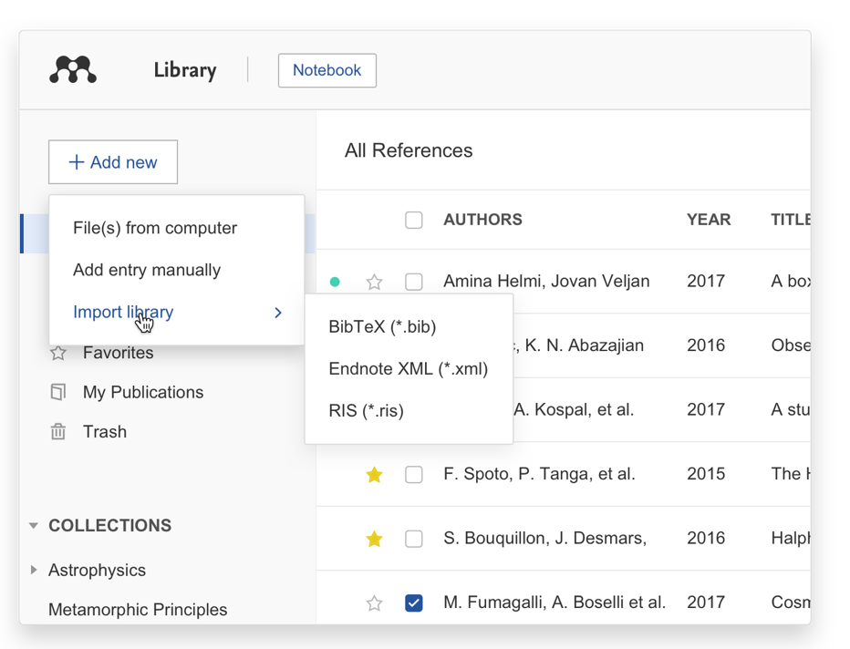

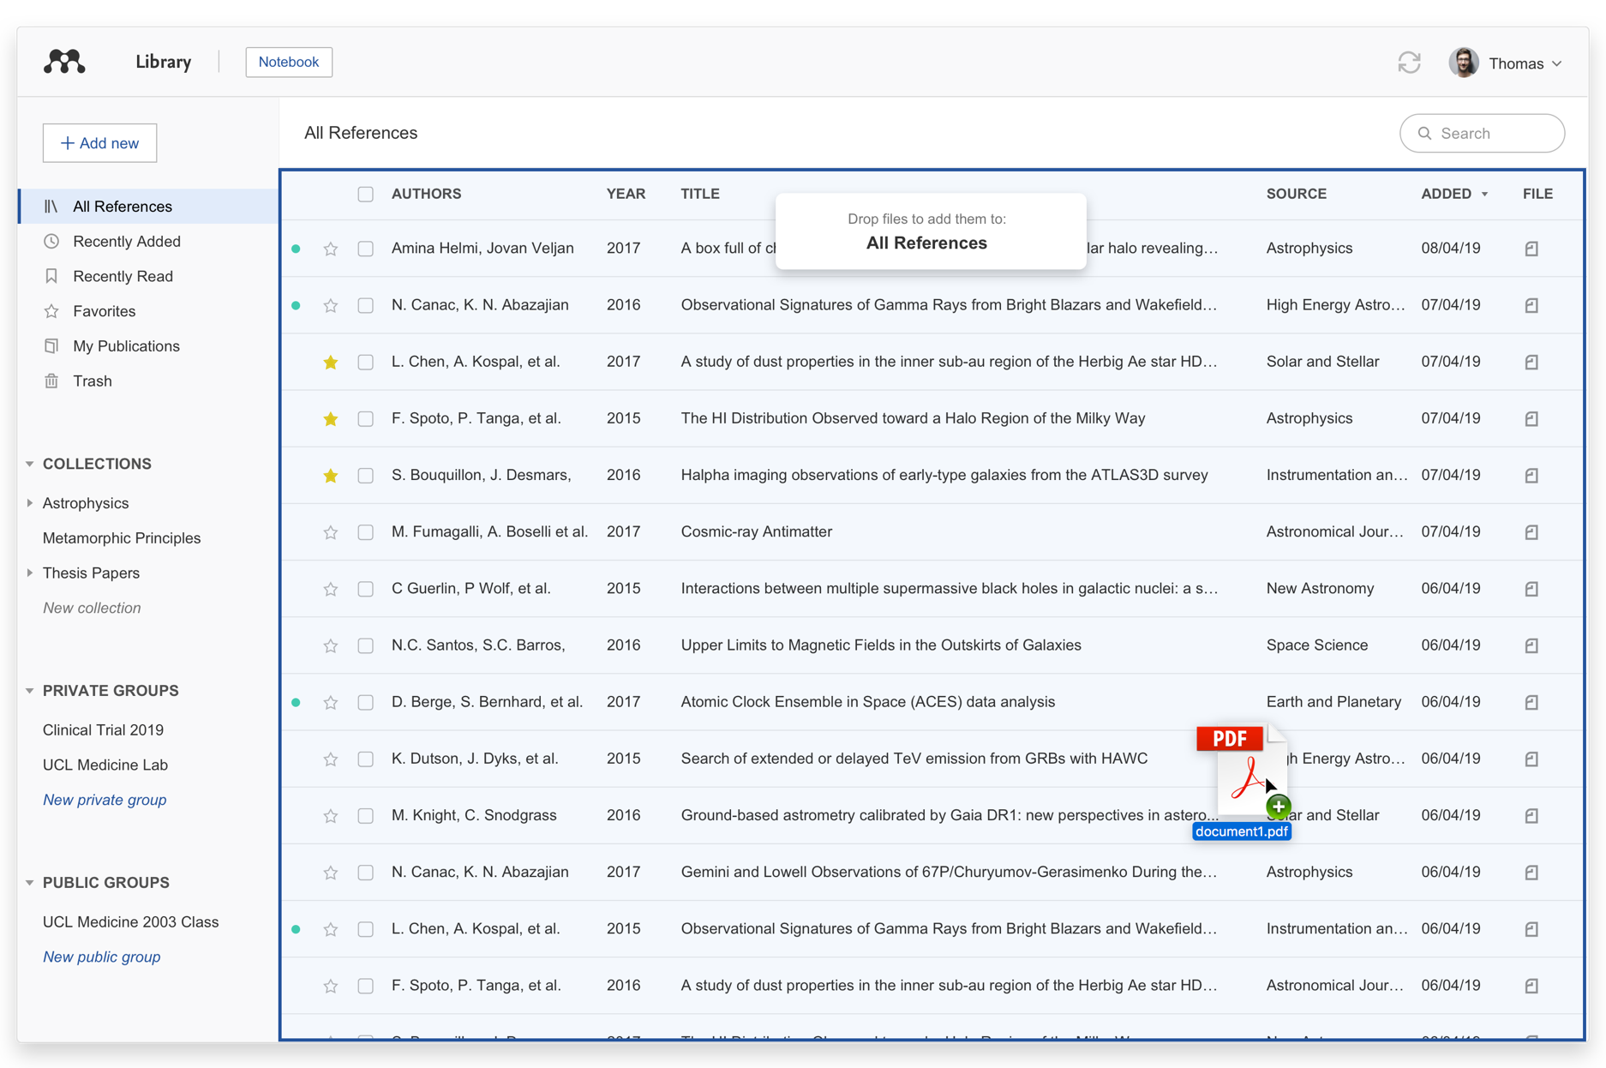

I have PDFs that I want to import

Drag and drop PDFs
Add references to your Mendeley library by dragging and dropping a PDF into the Mendeley Reference Manager window. You can also drag multiple PDFs into your library at the same time. Mendeley will automatically extract the metadata from the PDF(s) and create a library entry.

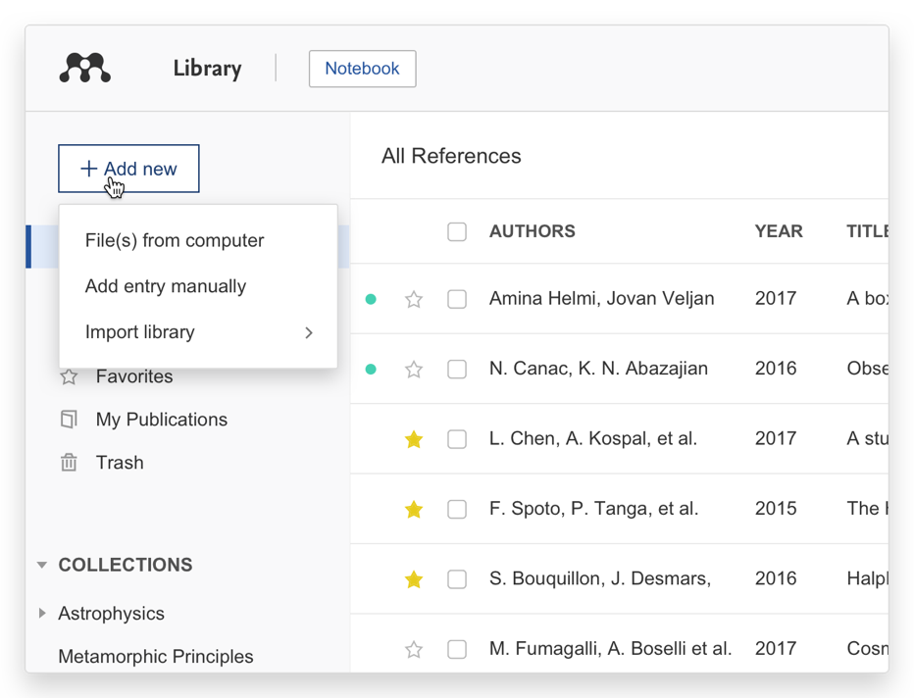

Browse for files
Use the 'File(s) from computer’ option in the '+ Add new' menu to select a reference from your computer and add it to your Mendeley library.

2. How to make a searching and organizing references?
Easily find references you're looking for and organize them based on your workflow

2.1 Smart Collections
Mendeley Reference Manager automatically organizes your references into smart collections.
- Recently Added - Displays the references added to your library in the last 30 days.
- Recently Read - Displays the references for PDFs opened in the last 30 days.
- Favorites - ‘Star’ a reference to automatically add it to your ‘Favorites’ collection.
- My Publications - This collection displays the publications that you have authored and claimed through the Scopus Author Profile. Go to your online Mendeley profile to view and add your authored publications.
- Trash - Displays the references that you have deleted from your library.

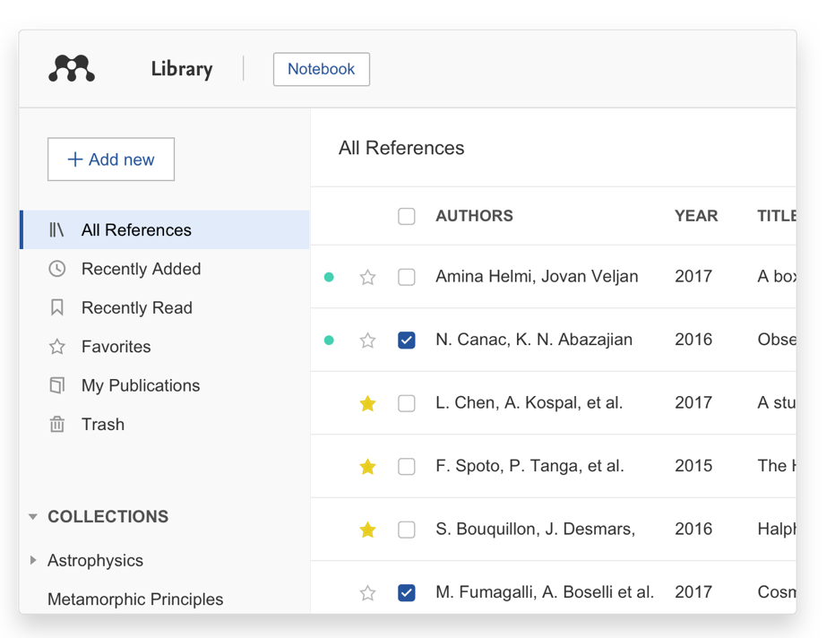

2.2 Using search to retrieve references
Mendeley Reference Manager search allows you to quickly retrieve your references.
Enter a search term in the field then press enter and Mendeley Reference Manager will return results based on the reference title, author, year or source. The search tool also is context-specific so will return results based on the collection you are currently viewing. You can use this to quickly pinpoint specific references.
To search your entire library ensure that ‘All References’ is selected.

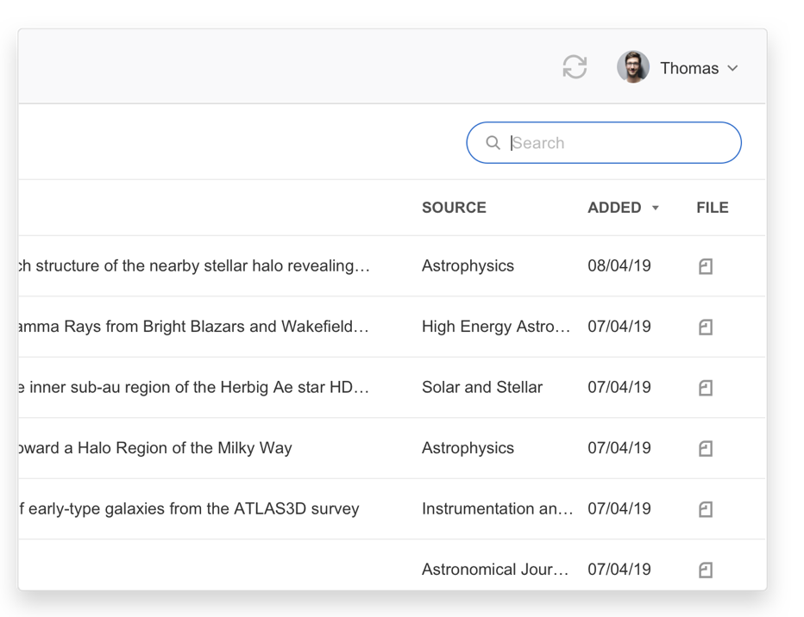

3. How to read and annotating documents?
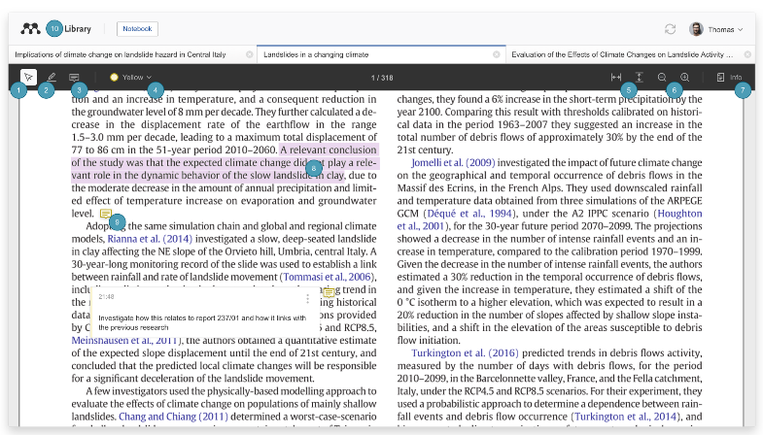

3.1 Read and annotate
- Text select tool - Use this tool to select text within your document. You can use this to copy and paste relevant passages or to apply highlighting (see number 2).
- Highlight tool - Use this tool to apply highlighting to text within the document. The highlight tool will apply whichever color is currently set as active (see number 4).You can add highlights to your Notebook by selecting the highlight and selecting 'Add to Notebook'. For more details see the Notebook section below.

Read and annotate
- Text select tool - Use this tool to select text within your document. You can use this to copy and paste relevant passages or to apply highlighting (see number 2).
- Highlight tool - Use this tool to apply highlighting to text within the document. The highlight tool will apply whichever color is currently set as active (see number 4).You can add highlights to your Notebook by selecting the highlight and selecting 'Add to Notebook'. For more details see the Notebook section below.
- Sticky Note tool - Use this tool to create sticky notes at specific locations within the document. Select wherever you want the note to appear (see number 9 for an example of a note within a document).
- Color selection - Mendeley Reference Manager supports highlighting in a number of different colors. Use this menu to select the active color. Notes and highlights that you create will use this color.
- Fit to width or height - Use these buttons to fit the PDF to the available width or height.
- Zoom - Use these buttons to zoom into and out of the PDF.
- Info - Use this button to open the Info panel. For more details about the tabs in the Info panel see the ‘Annotations’ tab and Mendeley Notebook sections below.
- Highlighted text - Select a passage of highlighted text to modify or remove the highlighting or to add the highlight to your Notebook.
- Sticky note - Sticky notes within the document will be represented by icons. Select the icon to reveal the contents of the sticky note.
- Library - To navigate back to your references select the 'Library' button.

3.2 Keep all your thoughts in one place using Mendeley Notebook
Collect highlights and comments across the multiple PDFs you're reading and keep them all securely in one place using Mendeley Notebook.
Notebook pages aren't tied to a specific reference and allow you to add highlights from many PDFs to a single page. You can access the Notebook by selecting the 'Notebook' button above the PDF.
- Access your Notebook - Select the Notebook.
- See your Notebook pages - Select a title to open the page.
- Delete Notebook pages - Select the trash icon next to the page to delete it.
- Create new Notebook pages - Select this to create a new, blank page. You can create as many Notebook pages as you need.

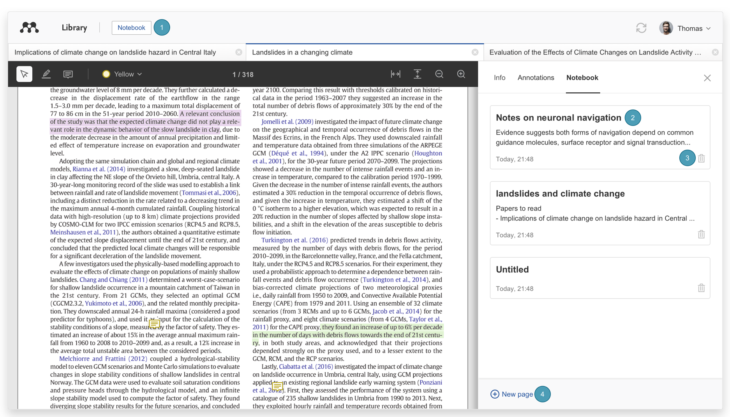

4. How to importing content from the web?

To importing content from the web is just add content from around the web directly into your Mendeley library
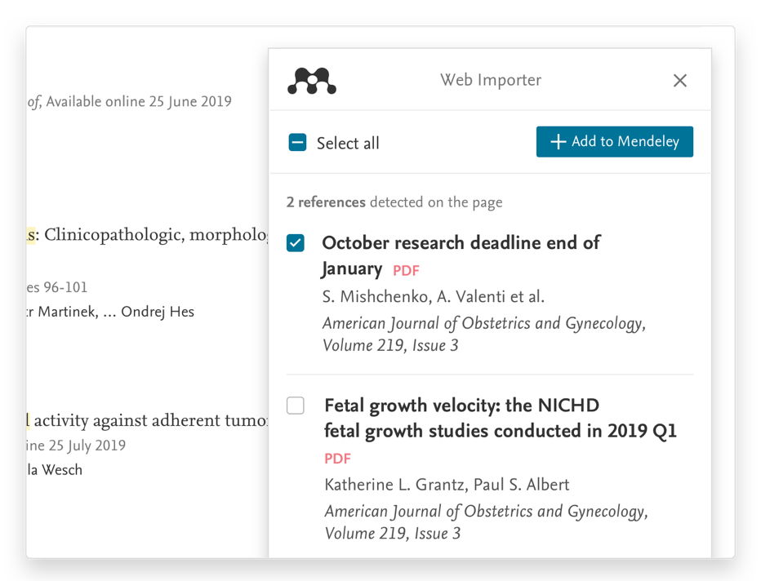
Import references from the web directly to your Mendeley library with Mendeley Web Importer. The browser extension detects article identifiers on the page you are viewing and automatically retrieves metadata and PDF full texts (where available) for you to add to your library.

Mendeley Web Importer is currently supported for Chrome and Firefox.

5. How to generate citation and bibliographies?

Getting started with Mendeley Cite
Generate citations and bibliographies and change your citation style in just a few clicks

What is Mendeley Cite?
Mendeley Cite add-in for Microsoft® Word allows you to easily insert references from your Mendeley library into your Word document, change your citation style and generate a bibliography - all without leaving your document.

You can use Mendeley Cite to:
- - Search for references in your Mendeley library and insert them into the document you're working on.
- - Select and insert individual or multiple references at once.
- - Create a bibliography of all the references you've cited.
- - Change to any of your preferred citation styles in just a few clicks.
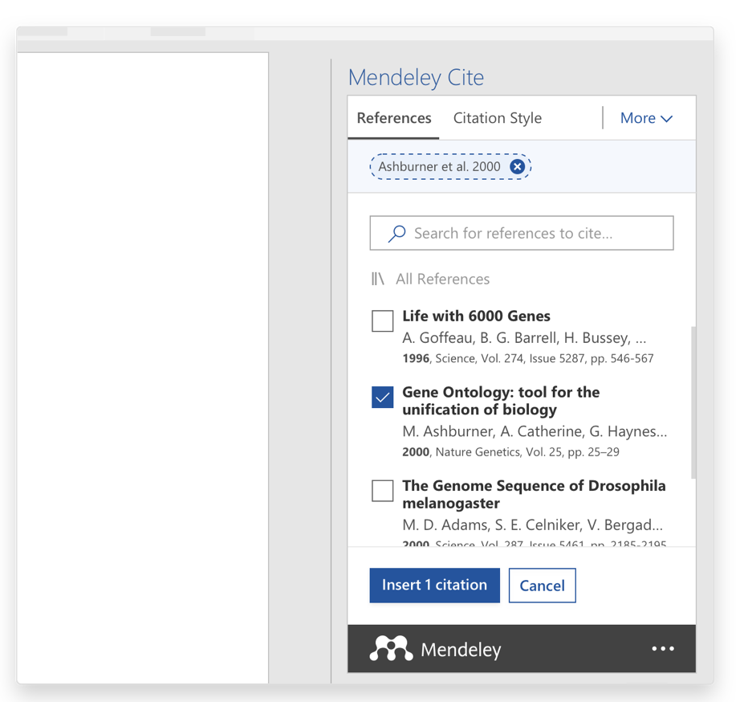

- - Cite without having Mendeley Reference Manager open or even installed - once you sign in to Mendeley Cite, your Mendeley library is downloaded from the cloud.
- - Keep sight of your Word document at all times - Mendeley Cite opens as a separate panel in Word alongside your document window, not over it.
- Mendeley Cite is a free, simple add-in for Microsoft Word versions 2016 and above, with the Microsoft Word app for iPad® and with Microsoft Word Online.

Copyright: https://www.mendeley.com/guides

